

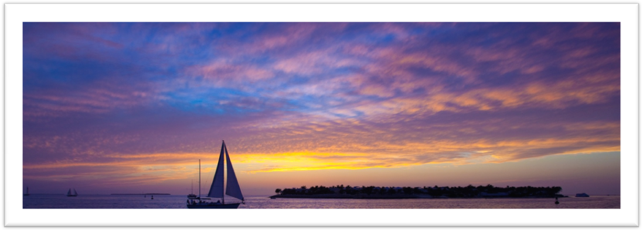

For Immediate Release:
Key West, Florida Thursday May 24, 2012

White Eagle Photography is proud to announce the release of "Key West Serenity”; the first image in the "Chasing the Sunset" series.

Sunsets in Key West are magical and breathe taking. From the water’s edge at Ft. Zachery to “The Top Bar” on the rooftop of La Concha to Mallory Square. Mallory Square hosts a sunset festival every night where locals and tourists alike come together enjoy the entertainers and to watch as the sun slips below the horizon. “Key West Serenity” shows the spectacular colors and clouds that a Key West sunset embodies. For days prior to capturing Key West Serenity it had been raining obscuring the sunset, but on this day, about two hours prior to sunset, the rain stopped, the clouds broke and the sky came alive with color.

Based in Plano, Texas White Eagle Photography is the creative center of Daniel White. Daniel’s passion for photography began at an early age when his grandparents gave him a camera for his birthday. From that gift they encouraged him to show the world through his eyes. Daniel is a Paramedic by training and dedication, and photographer by passion and commitment. When not answering the call to duty, Daniel can be found traveling the world, seeking fun and adventure from 180' beneath the waves to 45,000 in the heavens above. Along the way he captures spectacular and awe inspiring images for which “Key West Serenity” shows.

Now Key West Serenity can be yours in a 10"x20" Edition Frameless mount(s) starting at $ 395
1:2 panoramic* 10"x20" and larger 1:3 panoramic* 10"x30" and larger
* Custom sizes, framing or frameless options available.
For further information and to create your custom artwork contact the studio to make arrangements.
Contact Information:
Daniel White
www.WhiteEaglePhoto.com
7201 Springfield Dr Ste. 300
Plano, Texas 75025
(469) 795-1622
Info@WhiteEaglePhoto.com

